SIMATS ENGINEERING
Assignment Submission
COURSE NAME: OBJECT ORIENTED ANALYSIS AND DESIGN
COURSE CODE: CSA1103
Object-Oriented Analysis and UML-Based Design of an

AI-Enabled Smart Campus Management System (AISCaMS)
Assignment Weightage: 100% | Total Marks: 100

Code of Conduct
I Bhavya sree(192311388)certify that this submission is my original work and that I have adhered to the guidelines specified for this assessment.
I understand that any violation of academic integrity rules will result in disciplinary action.
Signature of the student: bhavya

Course Outcome Covered

Course Code & Name | CSA11 – Object Oriented Analysis and Design
Assignment Title | Object-Oriented Analysis and UML-Based Design of an AI-Enabled Smart Campus  Management System (AISCaMS)
Course Outcome(s) –  CO | CO1: Analyse the fundamentals of Object-Oriented Systems Development, including object basics, Object-Oriented Systems Development Life Cycle, Object-Oriented Methodologies, Model-Driven Development (MDD), and Agile practices.  CO2: Apply UML techniques including Use Case, Class, Interaction, State Transition, Activity, Package, Component, and Deployment Diagrams to model a software system.  CO3: Analyse objects, classes, attributes, methods, and relationships through Use Case Modelling, Object Analysis, Classification, and identification of object relationships.
Bloom's Taxonomy  Level | BL3 – Apply, BL4 – Analyse, BL5 – Evaluate, BL6 – Create
SDG Mapping (SDG  1–17) | SDG 4 – Quality Education | SDG 9 – Industry, Innovation and Infrastructure | SDG 11 – Sustainable Cities and Communities

Problem Analysis and Requirement Summary

Problem Domain Overview
The AI-Enabled Smart Campus Management System (AISCaMS) is envisioned as a centralised, intelligent platform that unifies academic, administrative, infrastructure, and student-support services on a single campus. The system must serve five distinct human actor groups — students, faculty, administrators, security personnel, and maintenance staff — each accessing the platform through a role-based interface tailored to their responsibilities. In addition, the system must integrate with two categories of non-human actors: an AI Recommendation Engine that suggests classrooms, facilities, and resources based on availability and historical usage patterns, and a network of IoT-enabled devices that continuously report room occupancy, environmental conditions, and equipment status.
The problem is inherently multi-domain: it spans academic scheduling (courses, classes, attendance), facility and resource management (classroom/lab bookings, events), infrastructure monitoring (IoT sensors, parking, equipment), and service operations (maintenance requests and resolution workflows). A sound object-oriented analysis must therefore decompose the problem into cohesive, loosely-coupled subsystems while preserving traceability between the stated requirements and the resulting design artefacts.

Functional Requirements (derived from the scenario)
- FR1: The system shall authenticate users and present role-based dashboards for students, faculty, administrators, security personnel, and maintenance staff.
- FR2: Students shall be able to view academic schedules, book classrooms/facilities, register for campus events, access digital services, and raise service requests.
- FR3: Faculty shall be able to manage classes, record attendance, manage academic activities, and request classroom/resource requirements.
- FR4: The system shall generate intelligent recommendations for suitable classrooms, facilities, and campus resources using availability data and historical usage patterns (AI Recommendation Engine).
- FR5: The system shall monitor campus infrastructure — classrooms, laboratories, smart devices, parking areas, and maintenance equipment — using IoT-enabled sensors reporting occupancy, environmental conditions, and equipment status.
- FR6: Maintenance personnel shall receive service requests, update repair status, and close resolved requests.
- FR7: Administrators shall manage users/roles, configure the system, and view consolidated reports and analytics.
- FR8: Security personnel shall monitor access points and infrastructure alerts generated from IoT data.

Non-Functional Requirements
- NFR1 – Usability: Role-based interfaces must be intuitive for non-technical users (students, maintenance staff).
- NFR2 – Scalability: The architecture must support a growing number of concurrent users, IoT devices, and campus buildings without redesign (addressed via a microservice-oriented component architecture, Section 11).
- NFR3 – Reliability & Availability: Booking, attendance, and maintenance services must remain available during peak academic hours.
- NFR4 – Maintainability: Modular packages (Section 10) and adherence to SOLID design principles (Section 14) shall minimise the cost of future change.
- NFR5 – Security: Role-based access control and authentication shall protect sensitive academic and personal data.
- NFR6 – Interoperability: The IoT integration layer shall support standard protocols (MQTT/HTTPS) to interface with heterogeneous smart devices.

Requirement Summary Table
Req. ID | Requirement | Primary Actor(s)
FR1 | Role-based authentication & dashboards | All Actors
FR2 | Schedule viewing, facility booking, event registration, service requests | Student
FR3 | Class, attendance & classroom-requirement management | Faculty
FR4 | AI-based recommendation of classrooms/resources | AI Recommendation Engine
FR5 | IoT-based infrastructure monitoring | IoT Devices, Admin, Security
FR6 | Maintenance request handling & repair status update | Maintenance Staff
FR7 | User/role management, system reports | Administrator
FR8 | Access & security monitoring | Security Personnel

Actor Identification

Actors represent any external entity — human or system — that interacts with AISCaMS to achieve a goal. Five human (primary) actors and two system (secondary) actors were identified directly from the problem scenario.
Actor | Type | Description / Goals
Student | Primary  (Human) | Views academic schedules, books classrooms/facilities, registers for events, accesses digital services, and raises service requests.
Faculty | Primary  (Human) | Manages classes, attendance, and academic activities; requests classroom/resource requirements.
Administrator | Primary  (Human) | Manages users and roles, configures the system, and reviews consolidated reports/analytics.
Security Personnel | Primary  (Human) | Monitors access points and responds to security/infrastructure alerts.
Maintenance Staff | Primary  (Human) | Receives maintenance/service requests and updates repair status until resolution.
AI Recommendation  Engine | Secondary  (System) | Analyses availability and usage-pattern data to recommend classrooms, facilities, and resources.
IoT Device / Sensor | Secondary  (System) | Reports room occupancy, environmental conditions, and equipment status to the platform in real time.

Use Case Descriptions

Detailed specifications for the principal use cases are provided below; remaining use cases shown in the Use Case Diagram (Section 4) follow the same template.
UC-03: Book Classroom / Facility
Use Case ID | UC-03
Use Case Name | Book Classroom / Facility
Primary Actor | Student, Faculty
Preconditions | Actor is authenticated; facility/classroom catalogue is available.
Main Flow | - Actor selects date, time, and facility type.  - System checks real-time availability against Booking and IoT occupancy data.  - If the preferred slot is unavailable, the system invokes the AI Recommendation Engine (include).  - AI Engine returns ranked alternative classrooms/facilities based on usage patterns.  - Actor confirms a slot.  - System creates a Booking record and updates classroom status.  - System sends a confirmation notification.
Alternate / Exception  Flow | If no slot is available even after AI suggestion, the system notifies the actor and the use case ends without a booking.
Postconditions | Booking is created and visible on the actor's schedule; classroom occupancy status is updated.
UC-05: Raise Service Request
Use Case ID | UC-05
Use Case Name | Raise Service Request
Primary Actor | Student, Faculty
Preconditions | Actor is authenticated.
Main Flow | - Actor selects a service category (e.g., maintenance, IT, housekeeping) and enters a description.  - System validates the request and creates a ServiceRequest with status 'Created'.
- System notifies the Maintenance Service (extend: Receive Maintenance Notification).
- Maintenance staff is assigned and updates status through the request lifecycle.
- System notifies the requester upon resolution.
Alternate / Exception  Flow | If the description is incomplete, the system prompts the actor to provide missing details before submission.
Postconditions | Request is logged, tracked, and eventually closed with a resolution history.
UC-06: Get AI Recommendation (included use case)
Use Case ID | UC-06
Use Case Name | Get AI Recommendation
Primary Actor | AI Recommendation Engine (invoked by UC-03/UC-05)
Preconditions | Availability data, historical usage data, and/or IoT sensor data are accessible.
Main Flow | - Requesting use case invokes the engine with contextual parameters (date, time, resource type).  - Engine queries current availability and historical usage patterns.  - Engine ranks candidate classrooms/resources by suitability score.  - Engine returns a ranked recommendation list to the requesting use case.
Alternate / Exception  Flow | If insufficient data exists, the engine returns a default nearest-available option.
Postconditions | A ranked list of recommendations is returned to the calling use case.
UC-13: Update Repair Status
Use Case ID | UC-13
Use Case Name | Update Repair Status
Primary Actor | Maintenance Staff
Preconditions | Maintenance staff is authenticated and has an assigned MaintenanceTask.
Main Flow | - Staff opens the assigned task list.  - Staff selects a task and updates its status (In Progress / Resolved).  - System records resolution notes and timestamps.  - System triggers a notification to the original requester on resolution.
Alternate / Exception  Flow | If additional parts/approval are required, staff marks the task 'On Hold' with a reason.
Postconditions | Task status and ServiceRequest status are synchronised; requester is notified.
UC-09 / UC-15: Monitor Campus Infrastructure / Monitor IoT Sensor Data
Use Case ID | UC-09
Use Case Name | Monitor Campus Infrastructure
Primary Actor | Administrator, Security Personnel
Preconditions | IoT devices are registered and actively reporting.
Main Flow | - Actor opens the infrastructure monitoring dashboard.  - System includes UC-15 to continuously pull live sensor readings (occupancy, environment, equipment status).  - System flags anomalies (e.g., unauthorised occupancy, equipment failure) as alerts.  - Actor reviews alerts and takes appropriate action (e.g., raises a service request).
Alternate / Exception  Flow | If a sensor becomes unresponsive, the system flags the device as 'Offline' and logs the event.
Postconditions | Administrator/Security has an up-to-date operational view of campus infrastructure.

Use Case Diagram

The diagram below models the AISCaMS system boundary, its five human actors, the two system actors (AI
Recommendation Engine and IoT Device/Sensor), and their associated use cases, including <<include>> and <<extend>> relationships identified from the scenario.
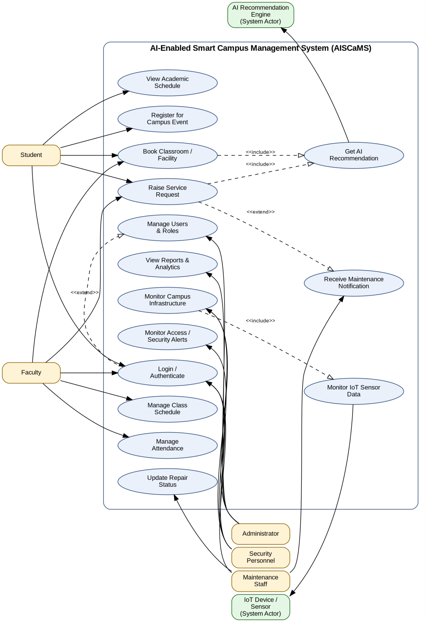
Figure 4.1 – Use Case Diagram for AISCaMS

Object and Class Identification

Candidate classes were identified using noun-phrase analysis of the problem statement, CRC-style brainstorming, and the responsibilities implied by the use cases in Section 3. Classes were then classified as Entity, Boundary, or Control per Jacobson's robustness-analysis convention, and refined for cohesion before being carried into the Class Diagram (Section 6).
Class | Category | Key Attributes | Key Responsibilities (Methods)
User (abstract) | Entity | userId, name, email, role | login(), logout(), updateProfile()
Student | Entity | regNo, program | viewSchedule(), bookFacility(), raiseServiceRequest()
Faculty | Entity | facultyId, department | manageAttendance(), manageClassSchedule(), requestClassroom()
Administrator | Entity | adminId | manageUsers(), viewReports(), configureSystem()
SecurityPersonnel | Entity | badgeId | monitorAccess(), raiseAlert()
MaintenanceStaff | Entity | staffId, skillArea | updateRepairStatus(), viewAssignedTasks()
ClassSchedule | Entity | scheduleId, courseCode, dayTime | createSchedule(), updateSchedule()
Attendance | Entity | attendanceId, date, status | markAttendance(), generateReport()
Classroom | Entity | roomId, capacity, building, status | checkAvailability(), updateStatus()
Facility | Entity | facilityId, type, location | checkAvailability()
Booking | Control/Entity | bookingId, dateTime, purpose, status | createBooking(), cancelBooking(), confirmBooking()
CampusEvent | Entity | eventId, title, venue, schedule | registerParticipant(), notifyParticipants()
ServiceRequest | Control/Entity | requestId, category, description, status | submitRequest(), assignRequest(), closeRequest()
MaintenanceTask | Entity | taskId, priority, resolutionNotes | updateStatus(), completeTask()
IoTDevice | Boundary/Entity | deviceId, deviceType, location | getStatus(), sendReading()
SensorReading | Entity | readingId, value, timestamp | recordReading()
RecommendationEngine | Control | modelVersion | recommendClassroom(), recommendResource(), analyzeUsagePattern()
Notification | Boundary | notifId, message, sentAt | send()
Report | Boundary | reportId, generatedOn | generate(), export()

Object Relationships Identified
- Inheritance (Generalisation): Student, Faculty, Administrator, SecurityPersonnel, and MaintenanceStaff all inherit common identity and authentication behaviour from the abstract class User.
- Association: Faculty–ClassSchedule (manages), Student–Booking (creates), Student/Faculty–
ServiceRequest (raises), MaintenanceStaff–MaintenanceTask (handles), Administrator–Report (generates), Student–CampusEvent (registers).
- Aggregation (whole–part, part can exist independently): Classroom aggregates IoTDevice (a device can be relocated/reassigned to another room).
- Composition (whole–part, part cannot exist independently): ServiceRequest is composed of exactly one MaintenanceTask lifecycle record that has no meaning outside its parent request; IoTDevice is composed of the SensorReading history it generates.
- Dependency (<<use>>): Booking and ServiceRequest depend on RecommendationEngine to obtain suggestions; RecommendationEngine depends on SensorReading data; ServiceRequest depends on Notification to alert stakeholders.

Class Diagram

The Class Diagram below realises the classes and relationships identified in Section 5. Multiplicities, an abstract User superclass with generalisation to five role subclasses, aggregation between Classroom and IoTDevice, composition between ServiceRequest/MaintenanceTask and IoTDevice/SensorReading, and dependency (<<use>>) relationships to the RecommendationEngine and Notification classes are shown explicitly.
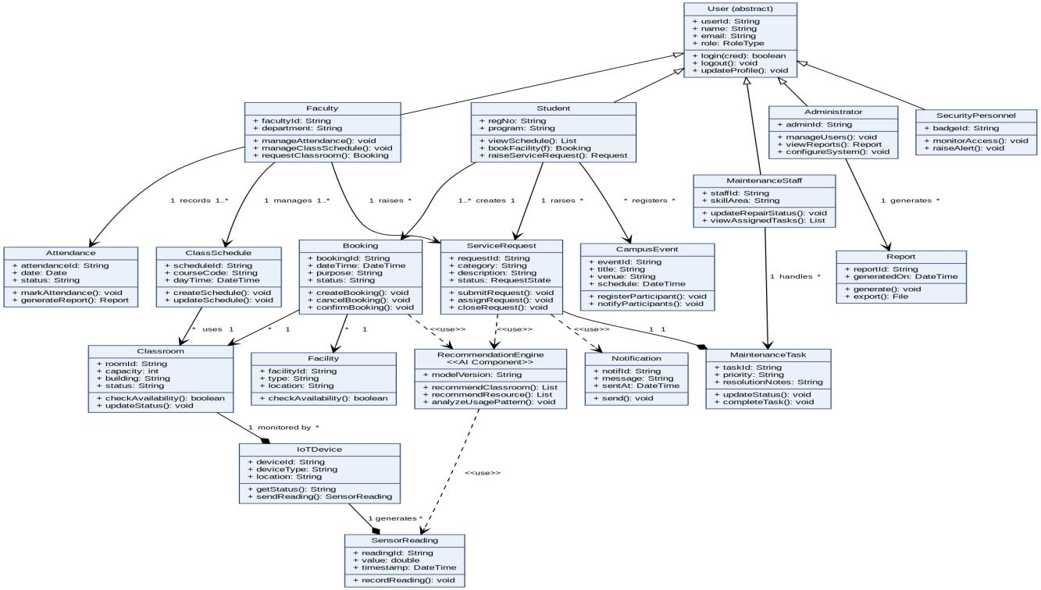
Figure 6.1 – Class Diagram for AISCaMS

Sequence / Interaction Diagram(s)

Two representative interaction scenarios are modelled: (a) booking a classroom/facility with an AI recommendation fallback, and (b) raising and resolving a maintenance service request. Both are directly traceable to the use cases in Section 3 and the classes/operations in Sections 5–6.

Sequence Diagram – Book Classroom / Facility with AI Recommendation (realises UC-03, UC-06)
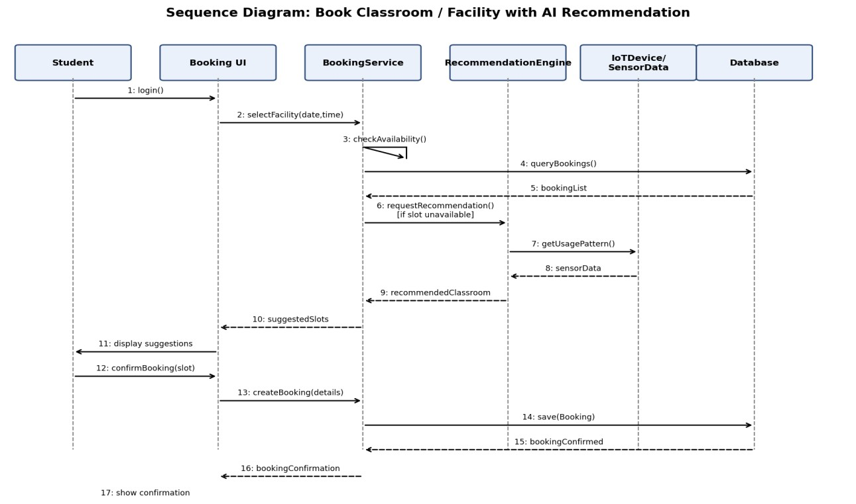
Figure 7.1 – Sequence Diagram: Book Classroom / Facility

Sequence Diagram – Raise & Resolve Maintenance Service Request (realises UC-05, UC13)
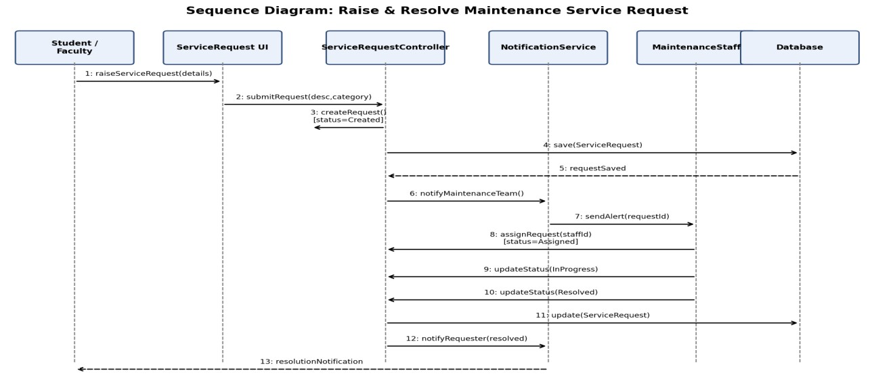
Figure 7.2 – Sequence Diagram: Maintenance Service Request Lifecycle

Activity Diagram
The Activity Diagram models the end-to-end workflow for the Classroom/Facility Booking process, including the decision point for availability, the AI-assisted alternative-suggestion branch, and the fork/join used to update IoT occupancy status and send a confirmation notification concurrently.
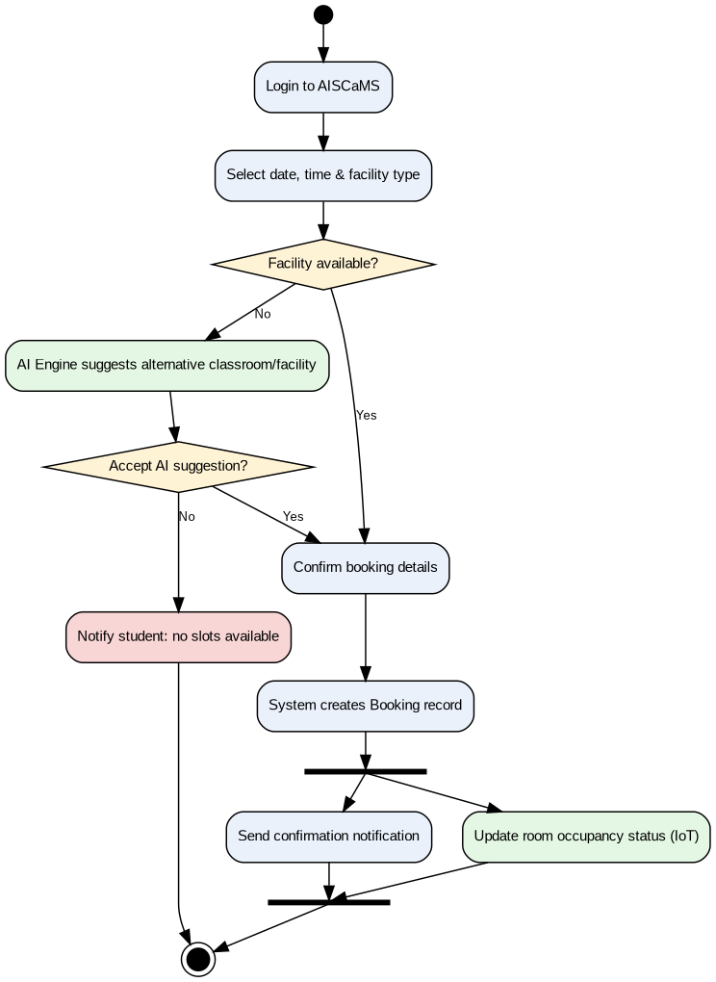
Figure 8.1 – Activity Diagram: Classroom / Facility Booking Process

State Transition Diagram

The lifecycle of a ServiceRequest object is modelled below. A request begins in the Created state, transitions to Assigned or Rejected, then to In Progress, Resolved, and finally Closed — with a Reopened path if the reported issue persists after resolution.
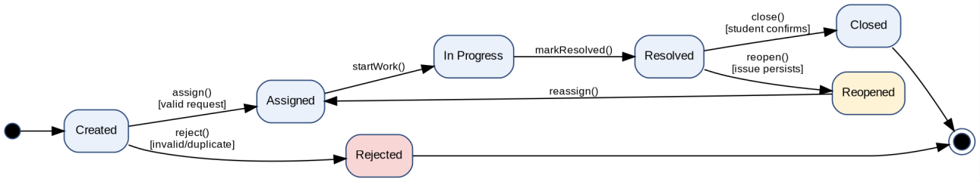
Figure 9.1 – State Transition Diagram: ServiceRequest Lifecycle

Package Diagram

AISCaMS is organised into eight cohesive packages following a layered architecture: Presentation, Application/Service, Domain/Model, Data Access, plus cross-cutting AI Recommendation, IoT Integration, Notification, and Security & Auth packages. Dependencies flow downward (import), preventing cyclic coupling between layers.
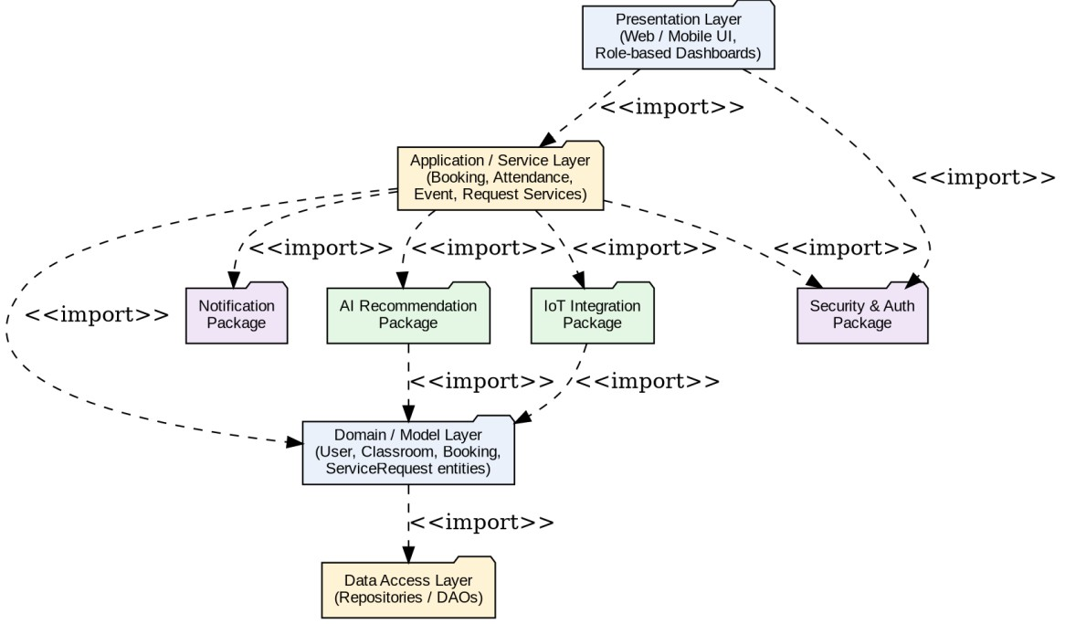
Figure 10.1 – Package Diagram for AISCaMS

Component Diagram

The Component Diagram decomposes the Application layer into deployable service components — Authentication,
Booking & Scheduling, Academic, AI Recommendation, IoT Integration, Notification, and Maintenance services — all reachable via a common API Gateway and sharing the Campus Database. This mirrors a microserviceoriented design that satisfies the scalability and maintainability non-functional requirements (Section 1.3).
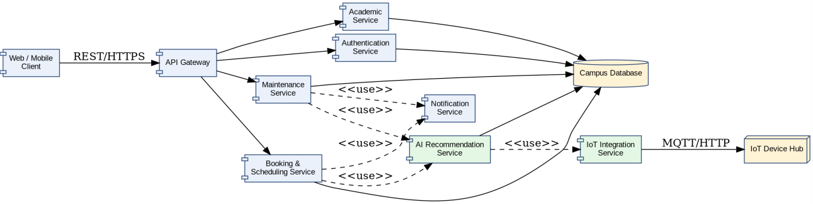
Figure 11.1 – Component Diagram for AISCaMS

Deployment Diagram

The Deployment Diagram maps the software components onto physical/virtual nodes: client devices communicate over HTTPS with a web/load-balancer server, which forwards requests to an application server hosting the microservices. The AI/ML server hosts the Recommendation Engine, IoT edge gateways aggregate readings from campus sensors, and a database server (with cloud storage for backups/reports) persists all data.
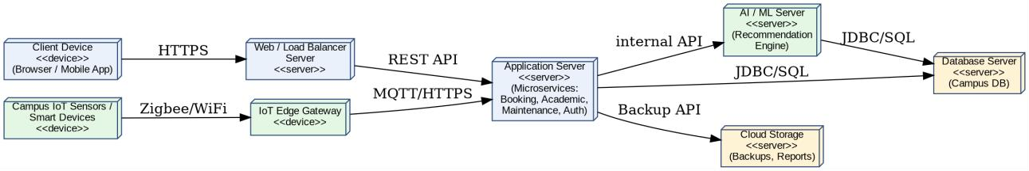
Figure 12.1 – Deployment Diagram for AISCaMS

Object Responsibility Analysis

CRC (Class-Responsibility-Collaborator) analysis was used to validate cohesion and appropriate responsibility assignment before finalising the Class Diagram. Four representative cards are presented below.
Class: Booking
Responsibilities  - Create, confirm, and cancel a classroom/facility reservation.  - Validate requested date/time against Classroom/Facility availability.  - Trigger AI recommendation when the requested slot is unavailable. | Collaborators  - Classroom  - Facility  - RecommendationEngine  - Student  - Notification

Class: ServiceRequest
Responsibilities  • Capture and validate a student/faculty service issue. | Collaborators  - Student  - Faculty
- Track status across its lifecycle (Created → Assigned → In Progress → Resolved → Closed).  - Notify the requester on status change. | - MaintenanceTask  - Notification  - MaintenanceStaff

Class: RecommendationEngine
Responsibilities  - Analyse historical usage patterns and current availability.  - Rank candidate classrooms/resources by suitability.  - Return recommendations to the calling service. | Collaborators  - Booking  - ServiceRequest  - SensorReading  - Classroom  - Facility

Class: IoTDevice
Responsibilities  - Report real-time occupancy, environmental, and equipment status.  - Generate and timestamp SensorReading records.  - Flag itself offline if it stops reporting. | Collaborators  - Classroom  - SensorReading  - RecommendationEngine  - Administrator/Security dashboard

Design Axioms, Principles and Design Pattern Justification

Design Axioms Applied (Suh's Axiomatic Design)
- Axiom 1 – Independence Axiom: Each package (Section 10) and each microservice component (Section 11) addresses one functional requirement area (booking, academic records, maintenance, AI recommendation, IoT), so a change to one does not ripple into unrelated modules.
- Axiom 2 – Information Axiom: Among designs that satisfy the independence axiom, the simplest structure was preferred — e.g., a single abstract User superclass instead of five unrelated authentication implementations minimises design complexity/information content.

Object-Oriented Design Principles
- Encapsulation: Each class exposes behaviour through public methods (e.g., checkAvailability(), updateStatus()) while keeping attributes private, so internal state (e.g., a Booking's status) can only change through controlled operations.
- Abstraction: The abstract User class captures common identity/authentication behaviour, hiding role-specific detail from collaborating classes that only need to know 'a User can login()'.
- Inheritance: Student, Faculty, Administrator, SecurityPersonnel, and MaintenanceStaff specialise User, reusing common attributes/operations and overriding role-specific behaviour where needed.
- Polymorphism: A uniform dashboard-rendering operation can invoke role-specific behaviour (e.g., getDashboardWidgets()) differently for each User subtype without the caller knowing the concrete type.
- High Cohesion: Classes such as Booking and ServiceRequest each own a single, well-defined responsibility (managing one reservation / one service issue respectively), keeping their methods tightly related.
- Low Coupling: The RecommendationEngine and NotificationService are accessed only through <<use>> dependencies from Booking/ServiceRequest, not by direct attribute access, so they can be modified or replaced independently.

Design Patterns Selected and Justified
Pattern | Category | Applied To / Justification
Singleton | Creational | RecommendationEngine and NotificationService are instantiated once per application context, since multiple instances would waste resources and could produce inconsistent recommendations/duplicate notifications.
Observer | Behavioural | IoTDevice publishes SensorReading updates; interested subscribers (Administrator dashboard, RecommendationEngine, Security alerts) are notified automatically without the device knowing their concrete types — a natural fit for real-time occupancy/equipment monitoring.
Strategy | Behavioural | The RecommendationEngine can switch between alternative ranking algorithms (e.g., occupancy-based vs. proximity-based recommendation strategy) at runtime without changing the calling Booking/ServiceRequest code.
Factory  Method | Creational | User subclass instantiation (Student, Faculty, Administrator, etc.) and ServiceRequest category creation are delegated to factory methods, isolating client code from concrete-class construction logic.
State | Behavioural | ServiceRequest's lifecycle (Created, Assigned, In Progress, Resolved, Closed — Figure 9.1) is implemented using the State pattern so that status-dependent behaviour (e.g., which transitions are legal) is encapsulated per state rather than in long conditional blocks.
MVC  (architectural) | Architectural | The overall Presentation / Application-Service / Domain layering (Figure 10.1) follows Model-View-Controller so that UI, business logic, and data remain independently testable and replaceable.

Assumptions and Constraints

Assumptions
- All campus buildings are equipped, or will be progressively equipped, with IoT sensors capable of reporting occupancy, environmental, and equipment-status data.
- A single authentication mechanism (institutional SSO or campus credentials) governs all five human actor roles.
- Historical usage data sufficient for meaningful AI recommendations accumulates within one academic term of go-live; a cold-start fallback (nearest available slot) is used until then.
- Network connectivity between IoT edge gateways and the application server is available with acceptable latency for near-real-time monitoring (not hard real-time/safety-critical).
- Payment processing for facility bookings, where applicable, is out of scope for this assignment and is treated as a future extension point.

Constraints
- The system boundary, actors, objects, classes, attributes, operations, and relationships must be clearly and consistently defined, as stated in the assignment brief.
- All UML diagrams must be mutually consistent — operations identified in the Class Diagram (Section 6) must support the interactions shown in the Sequence (Section 7) and Activity (Section 8) diagrams.
- The design must demonstrate encapsulation, abstraction, inheritance, polymorphism, cohesion, coupling, and responsibility assignment (addressed in Section 14).
- Design patterns must be selected and justified based on identified design problems, not applied speculatively (Section 14.3).
- The final model must document assumptions/constraints and ensure all UML models are complete, consistent, unambiguous, traceable, and feasible (Section 16).

Requirement-to-Use Case / Class Traceability

The matrix below demonstrates that every functional requirement (Section 1.2) is realised by at least one use case, which is in turn implemented by identifiable classes/operations, confirming completeness and consistency across the model.
Req.  ID | Use Case(s) | Realising Class(es) / Operation(s) | Diagram(s)
FR1 | Login/Authenticate | User.login(), User.logout() | Use Case, Class
FR2 | View Schedule, Book  Facility, Register Event,  Raise Request | Student.viewSchedule(), Student.bookFacility(),  CampusEvent.registerParticipant(),  Student.raiseServiceRequest() | Use Case,  Class, Sequence  7.1
FR3 | Manage Attendance,  Manage Class Schedule | Faculty.manageAttendance(),  Faculty.manageClassSchedule(),  ClassSchedule.createSchedule() | Use Case, Class
FR4 | Get AI Recommendation | RecommendationEngine.recommendClassroom(), recommendResource() | Use Case,  Class, Sequence  7.1
FR5 | Monitor Infrastructure,  Monitor IoT Sensor Data | IoTDevice.getStatus(), sendReading(),  SensorReading.recordReading() | Use Case,  Class,  Component,  Deployment
FR6 | Raise Service Request,  Update Repair Status | ServiceRequest lifecycle, MaintenanceTask.updateStatus() | Use Case,  Class, Sequence  7.2, State
FR7 | Manage Users, View  Reports | Administrator.manageUsers(), Report.generate() | Use Case, Class
FR8 | Monitor Access/Security  Alerts | SecurityPersonnel.monitorAccess(), raiseAlert() | Use Case, Class
Traceability confirms that all eight functional requirements are covered end-to-end — from actor-facing use cases, through class operations, to the interaction, state, and architectural diagrams — with no orphaned requirements or unsupported diagram elements.

Implementation / Prototype and Results

A minimal object-oriented prototype was implemented in Python to validate that the class structure, responsibilities, and the classroom-booking-with-AI-recommendation workflow (Sections 6 and 7.1) are internally consistent and executable. The prototype implements the User hierarchy (with inheritance), the Classroom, Booking, ServiceRequest, and a simplified RecommendationEngine using the Strategy pattern for ranking, and the Observer pattern for IoT sensor updates.

Prototype Code (excerpt)
class User: def __init__(self, user_id, name, role): self.user_id, self.name, self.role = user_id, name, role def login(self):
return f"{self.name} ({self.role}) logged in"

class Student(User): def __init__(self, user_id, name, reg_no):
super().__init__(user_id, name, "Student") self.reg_no = reg_no

class Classroom: def __init__(self, room_id, capacity, building): self.room_id, self.capacity, self.building = room_id, capacity, building self.status = "Available" def check_availability(self):
return self.status == "Available"

class RecommendationEngine: # Strategy pattern def __init__(self, strategy): self.strategy = strategy def recommend(self, rooms):
return self.strategy(rooms)

def usage_based_strategy(rooms):
return sorted(rooms, key=lambda r: r.capacity, reverse=True)

class Booking:
def __init__(self, booking_id, student, room):
self.booking_id, self.student, self.room = booking_id, student, room self.status = "Pending" def confirm(self): self.room.status = "Booked" self.status = "Confirmed"
return f"Booking {self.booking_id} confirmed for {self.room.room_id}"

# --- driver / simulation ---
rooms = [Classroom("C101", 60, "Block A"), Classroom("C102", 40, "Block A")] rooms[0].status = "Booked" # simulate C101 unavailable available = [r for r in rooms if r.check_availability()] engine = RecommendationEngine(usage_based_strategy) ranked = engine.recommend(available)

s1 = Student("S001", "Aditi Rao", "REG2026CS041") print(s1.login())
booking = Booking("BK1001", s1, ranked[0]) print(booking.confirm())

Sample Execution Output
Aditi Rao (Student) logged in
Booking BK1001 confirmed for C102
The output confirms the intended behaviour: Classroom C101 was already booked, so the RecommendationEngine (using the usage-based Strategy) ranked and returned the next best available room, C102, which the Booking object then confirmed — exactly mirroring the flow modelled in the Activity Diagram (Figure 8.1) and Sequence Diagram (Figure 7.1).

Result Summary
- The class hierarchy (User → Student) compiled and executed correctly, validating the inheritance relationship in Figure 6.1.
- The Strategy-pattern RecommendationEngine successfully substituted an alternative classroom when the first choice was unavailable, validating the decision logic in Figure 8.1 and the <<include>> relationship in Figure 4.1 (UC-03 → UC-06).
- The Booking.confirm() operation correctly updated Classroom.status, demonstrating encapsulated state change consistent with Section 14.2.
- The full source code and additional test scenarios (ServiceRequest lifecycle, Observer-based IoT notification) are included in the project GitHub repository referenced in Section 19.

Reflection on Design Decisions and Learning Outcomes

Design Decisions and Trade-offs
Modelling AISCaMS surfaced several genuine design trade-offs. First, deciding between a single monolithic User class with a role attribute versus a full inheritance hierarchy (User →
Student/Faculty/Administrator/SecurityPersonnel/MaintenanceStaff) required weighing simplicity against extensibility; the hierarchy was chosen because each role has materially different attributes and operations (e.g., Faculty.manageAttendance() has no analogue for Security Personnel), and the Independence Axiom (Section 14.1) favours separating unrelated responsibilities. Second, choosing aggregation (not composition) between Classroom and IoTDevice reflects the real-world possibility that a sensor can be uninstalled and relocated to another room without the Classroom object ceasing to exist — a subtlety that is easy to model incorrectly without careful requirements analysis.
Introducing the AI Recommendation Engine as a first-class Control-type class, rather than embedding recommendation logic directly inside Booking or ServiceRequest, was a deliberate application of low coupling and the Strategy pattern: it keeps the ranking algorithm swappable and testable in isolation, and prevents the Booking class from growing multiple, unrelated responsibilities (violating the Single Responsibility Principle).

Challenges Encountered
- Maintaining consistency across seven UML diagram types was the single largest challenge — every operation appearing in a Sequence Diagram had to be traceable back to a Class Diagram method, which required several iterations of the Class Diagram after the Sequence Diagrams were drafted.
- Distinguishing aggregation from composition for IoT devices and sensor readings required explicit reasoning about object lifecycle dependency rather than relying on intuition.
- Balancing the scope of a centralised 'smart campus' platform against the practical limits of a single assignment required scoping decisions (e.g., excluding payment processing) that were documented explicitly as assumptions (Section 15.1) rather than silently ignored.

OOAD Concepts Learned
- Practical application of Jacobson's robustness analysis (Entity/Boundary/Control classification) to move systematically from a natural-language problem statement to a candidate class list.
- Concrete, scenario-driven experience distinguishing association, aggregation, composition, and dependency relationships, and expressing them with correct multiplicities.
- Hands-on justification (not just definition) of design patterns — selecting Singleton, Observer, Strategy, Factory Method, and State patterns based on specific design problems identified in the AISCaMS scenario, rather than applying them by rote.
- End-to-end traceability discipline: verifying that requirements → use cases → classes → interactions → architecture form an unbroken, auditable chain (Section 16).

Relevance of the Selected Sustainable Development Goals
SDG 4 (Quality Education) is directly advanced because AISCaMS streamlines academic scheduling, attendance, and classroom access — reducing administrative friction so that more institutional time and resources can be directed toward teaching and learning quality. SDG 9 (Industry, Innovation and Infrastructure) is reflected in the system's use of IoT sensing and an AI recommendation layer to modernise and optimise the utilisation of physical campus infrastructure, an example of applying innovative digital infrastructure to an existing institutional asset base. SDG 11 (Sustainable Cities and Communities) is relevant because the smart, data-driven monitoring of classrooms, parking, and equipment (Sections 9–12) supports more efficient, lower-waste use of shared campus space and resources — a small-scale analogue of the smart-city principles the goal promotes. Together, these SDGs frame AISCaMS not merely as an administrative convenience but as a demonstrable case study in applying OOAD and intelligent systems design to sustainable institutional operations.

GitHub Upload

Per the assignment guidelines, the complete design artefact set — this report, all UML diagram source files, and the prototype source code (Section 17) — should be uploaded to a GitHub repository as the final submission step.
Suggested repository structure:
- /docs — this report (DOCX/PDF) and the Problem Statement/Annexure.
- /diagrams — source files and exported images for Use Case, Class, Sequence, Activity, State, Package, Component, and Deployment diagrams.
- /src — prototype source code (Section 17) with a README describing how to run it.
- /traceability — the requirement-to-use-case/class traceability matrix (Section 16) in spreadsheet form.

